Game Development using Unity

UNIT-1
Introduction to Game Development: Overview of game development, history of games, basics of game engine. Different roles in game development. Getting Started with Unity: Installation, version control, Unity interface, importing or creating assets, game objects and game components, scripts in unity.

UNIT-2
Game Development in Unity: Render pipeline, Package manager, 2D vs 3D, visual scripting, post processing, shader graph, pro builder.Scripting in Unity: C# programming in Unity, basic C# concepts, introduction to unit tests, game physics, scripting game mechanics, game state management, player input and controls.

UNIT-3
Game Development in Unity Continued: UI Toolkit, assembly definition, nav mesh, Input system, Animation, Json utility, Addressable, Multiplayer, Localization. Scripting in Unity
Continued: NPCs in games, Inventory system, object pool, Unit test, SOLID principle, Design patterns, Debugging and profiling, Dots and ECSContemporary Issues & Opportunities: Trends, challenges, and case studies in modern game development.

Unity Lab Manual

Lab 1: Create a Balance Primitive Structure.
Objective: Get comfortable with the Unity interface.
Task: Create a new project, explore the Hierarchy, Scene view, Game view, and Inspector. Create a basic scene containing a Plane (floor), three Cubes, and a Sphere. Organize them using an empty GameObject named _Environment.

Lab 2: Materials and Asset Importing
Objective: Learn to import external assets and apply textures.
Task: Import a custom 2D image or 3D asset package into the project. Create three unique Materials with different colors and smoothness levels, and assign them to your 3D shapes.

Lab 3: Basic Transform Manipulation via Script
Objective: Understand GameObjects, Components, and basic C# scripting.
Task: Write a simple C# script called RotateObject. Attach it to a Cube and make the object rotate continuously along the Y-axis using Transform.Rotate and Time.deltaTime.

Lab 4: Instantiation and Destruction
Objective: Learn to dynamically create and destroy GameObjects.
Task: Create a Prefab from a Sphere asset. Write a script that instantiates (spawns) this sphere prefab at a specific position every time the player presses the Spacebar, and destroys the spawned object automatically after 3 seconds.

Lab 5: 3D Cube Movement & Boundary Checks
Objective: Work with 3D elements and player input.
Task: Set up a 3D scene. Use the keyboard arrows or WASD keys (Input.GetAxis) to move a 3D character cube across the screen.

Lab 6: 2D Sprite Movement & Boundary Checks
Objective: Work with 2D elements and player input.
Task: Set up a 2D scene. Use the keyboard arrows or WASD keys (Input.GetAxis) to move a 2D character sprite across the screen. Add a script condition to prevent the sprite from moving off-screen.

Lab 7: Rigidbody Physics and Colliders
Objective: Understand Unity's physics engine and basic collision detection.
Task: Create a rolling ball mechanic. Add a Rigidbody component to a sphere. Set up a wall obstacle with a BoxCollider and implement OnCollisionEnter to print a message to the console when the ball hits the wall.

Lab 8: Custom Shaders with Shader Graph
Objective: Introduction to visual shader editing.
Task: Open Unity’s Shader Graph. Create a simple shader for tailing and offset a road texture and apply it to a 3D material to give an item a distinct "road" moving look.

Lab 9: Post-Processing Effects
Objective: Enhance game visuals using the render pipeline features.
Task: Install and set up a Post-Processing profile in your scene. Configure a Volume component to add subtle Vignette, Bloom, and Color Grading effects to alter the mood of the environment.

Lab 10: Basic Transform Manipulation via Visual Scripting
Objective: Understand GameObjects, Components, and visual scripting.
Task: Write a simple visual scripting called RotateObject. Attach it to a Cube and make the object rotate continuously along the Y-axis using Transform.Rotate and Time.deltaTime.

Lab 11: Creating a UI Canvas
Objective: Build an interactive user interface.
Task: Use the UI Toolkit (or Canvas system) to design a basic HUD. Display a live text counter for the "Score" and a Slider bar representing "Player Health". Update these UI elements dynamically from your player script.

Lab 12: Game States
Objective: Handle game logics between different states.
Task: To design and implement a centralized Game State Manager using a Finite State Machine (FSM) architecture. Create a C# script to handle the game states.

Lab 13: Pathfinding with NavMesh
Objective: Implement AI navigation for Non-Player Characters.
Task: Bake a static environment map using Unity's NavMesh. Create an NPC GameObject with a NavMeshAgent component and write a short script making it dynamically chase a moving player target across the surface.

Lab 14: JSON Serialization for login system
Objective: Learn data persistence mechanisms.
Task: Create a simple serializable C# data class to hold user data (e.g., user name, password). Use JsonUtility to save this data out to a local JSON text file and reload it when the game restarts.

Lab 15: Animation Trigger
Objective: Rotate a cube using the Animator controller.
Task: Create a cube and create a Rotate animation clip.

Lab 1: Create a Balanced Primitive Structure

Objective
Create a balanced structure using Unity primitive objects and Rigidbody physics components to observe how mass affects balance.

Step 1: Create a New Unity Project
- Open Unity Hub.
- Click New Project.
- Select 3D (Core) template.
- Enter the project name BalancedPrimitiveStructure.
- Choose a project location.
- Click Create Project.

Step 2: Create a New Scene
- In the Project Window, navigate to the Assets folder.
- Right-click and select Create → Folder.
- Name the folder Scenes.
- Open the Scenes folder.
- Right-click and select Create → Scene.
- Name the scene Primitive Structure.
- Double-click the scene to open it.
- Save the scene (Ctrl + S).

Step 3: Create a Plane
- In the Hierarchy Window, right-click.
- Select 3D Object → Plane.
- Select the Plane.
- In the Inspector Window, click the gear icon (or three dots) in the Transform component.
- Select Reset.

Step 4: Create the Base Support Cube
- Right-click in the Hierarchy.
- Select 3D Object → Cube.
- Rename it Base Support.
- Set the Transform values:
  - Position (0, -0.03, 0)
  - Rotation (45, 90,0)

Step 5: Create the Balance Beam
- Create another Cube.
- Rename it Balance Beam.
- Set the Transform values:
  - Position (0, 0.72, 0)
  - Scale(10, 0.1, 1)

Step 6: Create the Left Weight
- Create a new Cube.
- Rename it Left Weight.
- Set the Transform values:
  - Position (-4.5, 1.27, 0)
- Add a Rigidbody:
  - Click Add Component.
  - Search for Rigidbody.
  - Select Rigidbody.
- Set:
  - Mass = 2

Step 7: Create the First Right Weight
- Create another Cube.
- Rename it Right Weight 1.
- Set the Transform values:
  - Position (4.5, 1.27, 0)
- Add a Rigidbody component.
- Set:
  - Mass = 1

Step 8: Create the Second Right Weight
- Create another Cube.
- Rename it Right Weight 2.
- Set the Transform values:
  - Position (4.5, 2.27, 0)
- Add a Rigidbody component.
- Set:
  - Mass = 1

Step 9: Test the Balanced Structure
- Save the scene.
- Click the Play button at the top of the Unity Editor.
- Observe the behavior of the structure.

Expected Result
- The cube on the left has a mass of 2.
- The two cubes on the right each have a mass of 1.
- Since the total mass on both sides is equal (2 = 1 + 1), the beam should appear balanced.
- Unity physics demonstrates the concept of equilibrium and center of mass.

Screenshot
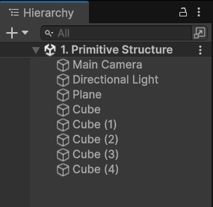
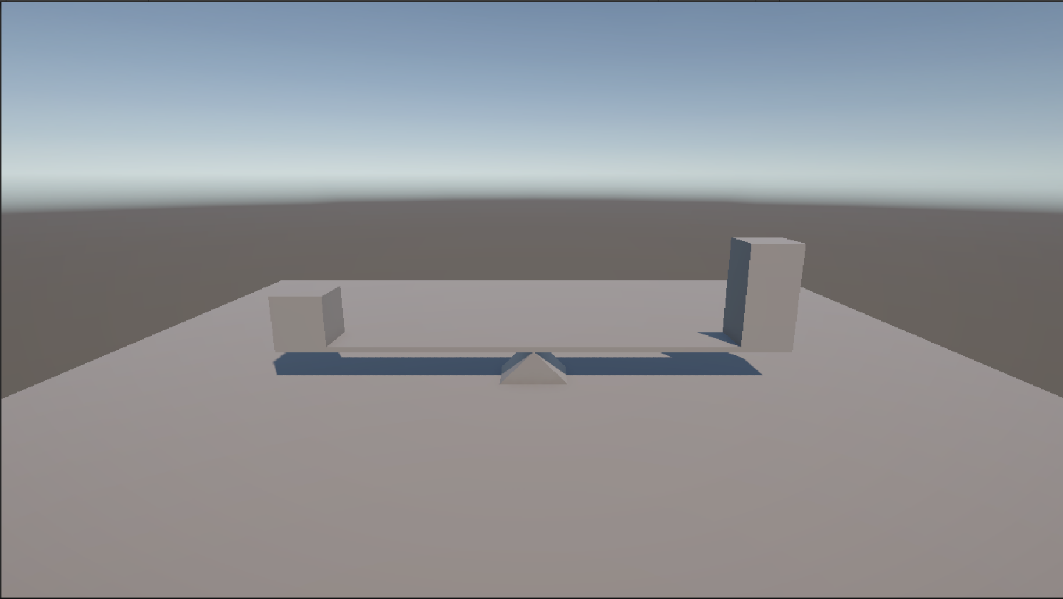

Lab 2: Applying Assets and Materials

Objective
Learn how to import textures, create a material, and apply it to a 3D object in Unity.

Step 1: Create a New Unity Project
- Open Unity Hub.
- Click New Project.
- Select the 3D (Core) template.
- Enter a project name.
- Choose a project location.
- Click Create Project.

Step 2: Create a New Scene
- In the Project Window, navigate to the Assets folder.
- Right-click and select Create → Scene.
- Rename the scene as Asset & Material.
- Double-click the scene to open it.
- Save the scene (Ctrl + S).

Step 3: Create a Plane
- In the Hierarchy Window, right-click.
- Select 3D Object → Plane.
- Select the Plane object.
- In the Inspector Window, click the gear icon (or three dots) in the Transform component.
- Select Reset.

Step 4: Import Texture Maps and Create a Material
- Import Texture Maps
- Open the folder containing the texture files.
- Drag and drop the following files into the Assets folder:
- Brick_Diffusion_Map (Albedo Texture)
- Brick_Normal_Map
- Create a Material
- In the Project Window, right-click inside the Assets folder.
- Select Create → Material.
- Rename the material as Asset_Material.

Step 5: Configure the Material
- Select Asset_Material.
- In the Inspector Window, locate the Base Map property.
- Drag the Diffusion Map texture into the Base Map slot.
- Locate the Normal Map property.
- Drag the Normal Map texture into the Normal Map slot.
- If Unity prompts "Fix Now" for the normal map, click Fix Now.
Note: Change the tiling as (3,3) for this project only.

Step 6: Apply the Material to the Plane
- Select the Plane object in the Hierarchy.
- Drag the Asset_Material from the Project Window onto the Plane.
OR
- In the Plane's Mesh Renderer component, drag the material into the Materials slot.

Expected Result
- The Plane displays the Diffusion (Albedo) texture.
- Surface details from the Normal Map are visible when light falls on the Plane.
- The Plane appears more realistic with texture and surface depth effects.

Screenshots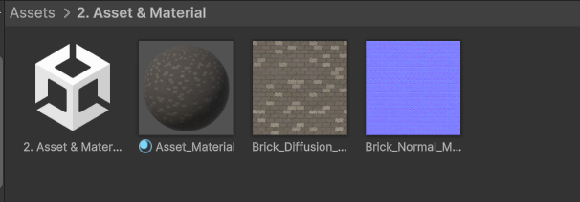
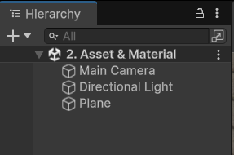
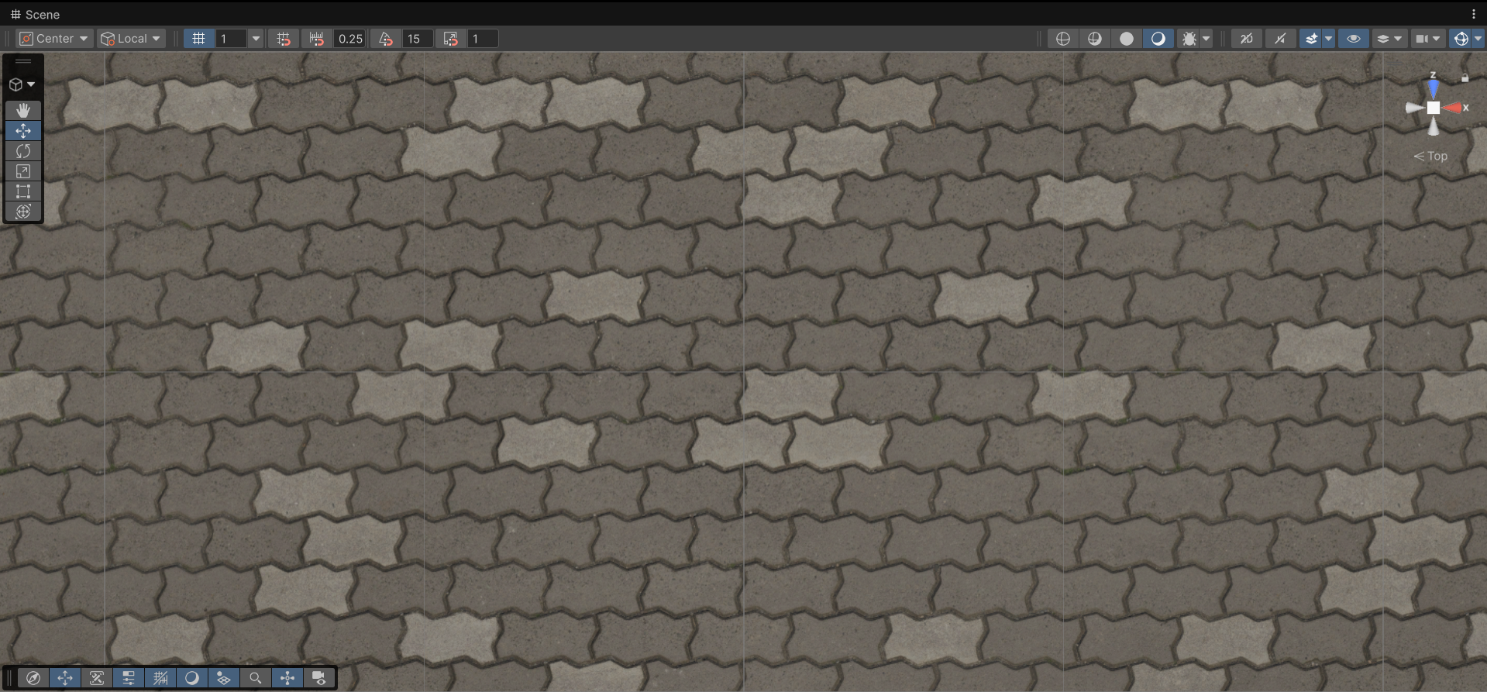

Lab 3: Basic Transform Manipulation via Script

Objective
Learn how to manipulate a GameObject's Transform component through scripting by continuously rotating a cube around its Y-axis.

Step 1: Create a New Unity Project
- Open Unity Hub.
- Click New Project.
- Select the 3D (Core) template.
- Enter a project name.
- Choose a project location.
- Click Create Project.

Step 2: Create a New Scene
- In the Project Window, right-click inside the Assets folder.
- Select Create → Scene.
- Rename the scene as Transform Manipulation.
- Double-click the scene to open it.
- Save the scene (Ctrl + S).

Step 3: Create a Cube
- In the Hierarchy Window, right-click.
- Select 3D Object → Cube.
- Rename the object as Cube.
- Select the Cube.
- In the Inspector Window, click the gear icon (or three dots) in the Transform component.
- Select Reset.

Step 4: Create a Script
- In the Project Window, right-click inside the Assets folder.
- Select Create → C# Script.
- Rename the script as RotateObject.
- Double-click the script to open it in Visual Studio or your preferred code editor.

Step 5: Write the Script

- Replace the existing code with the following:

using UnityEngine;

public class RotateObject : MonoBehaviour
{
[Header("Rotation Settings")]
[Tooltip("Rotation speed in degrees per second.")]
public float rotationSpeed = 50f;

// Update is called once per frame
void Update()
{
// Calculate the rotation amount for this frame
float rotationAmount = rotationSpeed * Time.deltaTime;

// Rotate only around the Y-axis (Up)
transform.Rotate(0f, rotationAmount, 0f);
}
}

Code Explanation
- rotationSpeed controls how fast the cube rotates.
- Time.deltaTime ensures smooth rotation regardless of frame rate.
- transform.Rotate() rotates the object every frame.
- The cube rotates only around the Y-axis.

Step 6: Attach the Script to the Cube
- Return to Unity.
- Wait for Unity to compile the script.
- Select the Cube GameObject in the Hierarchy.
- Drag the RotateObject script from the Project Window onto the Cube.
OR
- Click Add Component in the Inspector and search for RotateObject.
- Verify that the script appears in the Cube's Inspector.

Step 7: Play the Game
- Save the scene (Ctrl + S).
- Click the Play button at the top of the Unity Editor.
- Observe the Cube rotating continuously around its Y-axis.

Expected Result
- The Cube rotates smoothly around its vertical (Y) axis.
- The rotation speed is controlled by the Rotation Speed variable in the Inspector.
- Changing the value while the game is running affects the rotation speed.

Screenshots
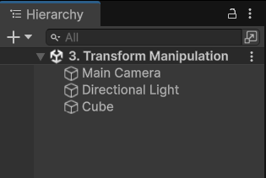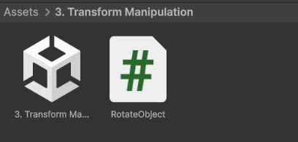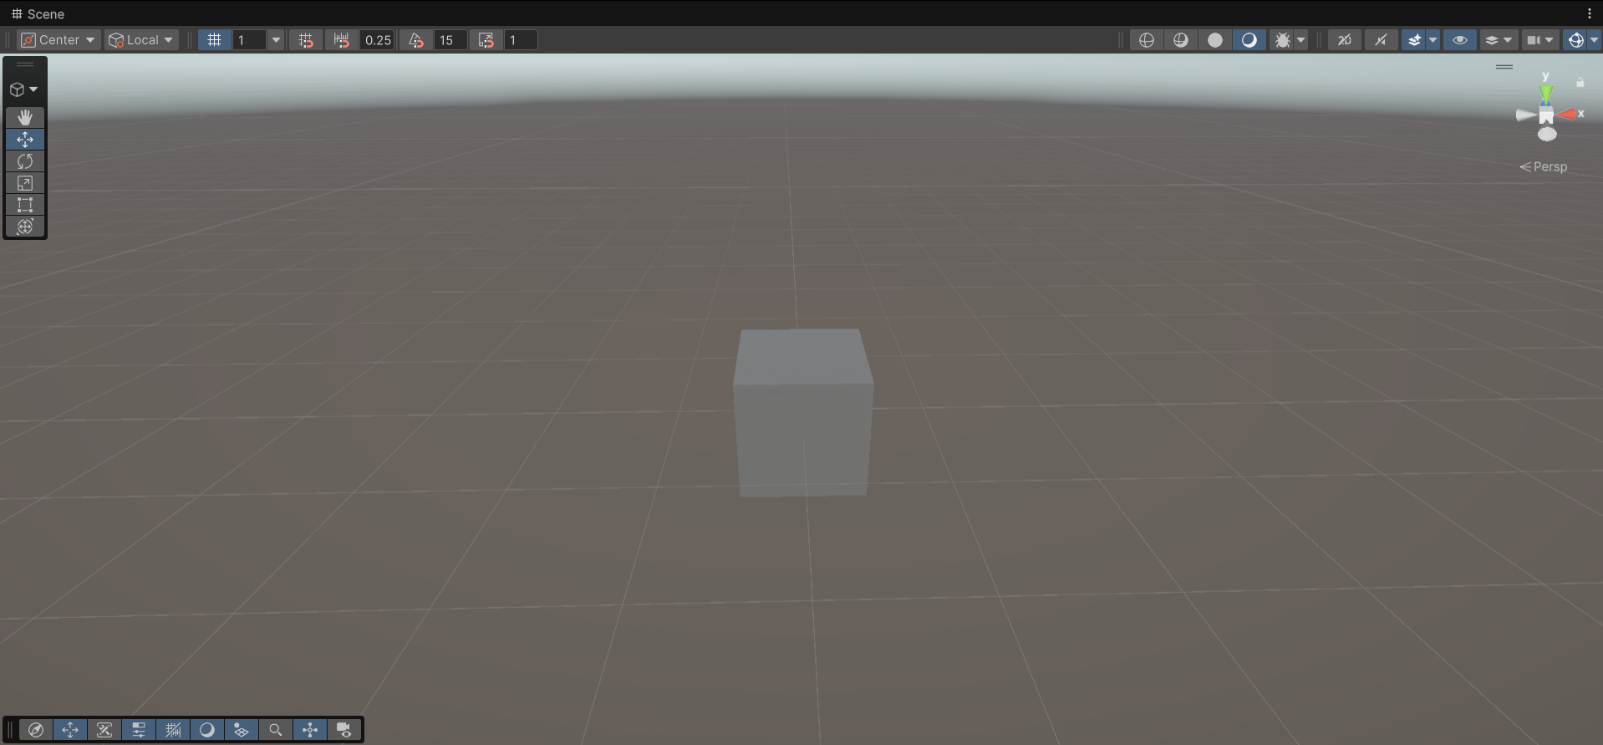

Lab 4: Instantiation and Destruction

Objective
Learn how to create a Prefab, instantiate (spawn) it using a script when the Spacebar is pressed, and automatically destroy the spawned object after 3 seconds.

Step 1: Create a New Unity Project
- Open Unity Hub.
- Click New Project.
- Select the 3D (Core) template.
- Enter a project name.
- Click Create Project.

Step 2: Create a New Scene
- In the Project Window, right-click inside the Assets folder.
- Select Create → Scene.
- Rename the scene as Prefab Spawn.
- Open and save the scene.

Step 3: Create a Sphere
- In the Hierarchy Window, right-click.
- Select 3D Object → Sphere.
- Rename it as SpherePrefab.
- Set its position to (0, 0.5, 0).

Step 4: Create a Prefab
- In the Project Window, create a folder named Prefabs.
- Drag the SpherePrefab GameObject from the Hierarchy into the Prefabs folder.
- A blue prefab asset is created.
- Delete the Sphere from the Hierarchy (the prefab asset remains in the Project window).

Step 5: Create an Empty GameObject
- Right-click in the Hierarchy.
- Select Create Empty.
- Rename it as Spawner.

Step 6: Create a Script
- In the Assets folder, right-click.
- Select Create → C# Script.
- Rename the script as SphereSpawner.
- Open the script in Visual Studio.

Step 7: Write the Script
- Replace the default code with:

using UnityEngine;

public class SphereSpawner : MonoBehaviour
{
[Header("Prefab Settings")]
public GameObject spherePrefab;

[Header("Spawn Position")]
public Vector3 spawnPosition = new Vector3(0, 1, 0);

void Update()
{
// Check if Spacebar is pressed
if (Input.GetKeyDown(KeyCode.Space))
{
// Spawn the sphere prefab
GameObject spawnedSphere = Instantiate(
spherePrefab,
spawnPosition,
Quaternion.identity);

// Destroy after 3 seconds
Destroy(spawnedSphere, 3f);
}
}
}

Step 8: Attach the Script
- Return to Unity.
- Select the Spawner GameObject.
- Click Add Component.
- Add the SphereSpawner script.

Step 9: Assign the Prefab
- Select the Spawner GameObject.
- In the Inspector, locate the Sphere Prefab field.
- Drag the SpherePrefab asset from the Prefabs folder into the field.

Step 10: Test the Project
- Save the scene.
- Click Play.
- Press the Spacebar.

Note: If you get any the error InvalidOperationException: You are trying to read Input using the UnityEngine.Input class, but you have switched active Input handling to Input System package in Player Settings.
- Go to Edit > Project Settings from the top menu.
- Select the Player category on the left panel.
- Expand the Other Settings dropdown on the right side.
- Scroll down to the Configuration section and find Active Input Handling.
- Change the dropdown selection from Input System Package (New) to Both.
- Unity will prompt you to apply the changes and restart the editor. Click Apply.

Expected Result
- A Sphere appears at position (0, 1, 0).
- Every time the Spacebar is pressed, a new Sphere is spawned.
- Each spawned Sphere automatically disappears after 3 seconds.

Screenshots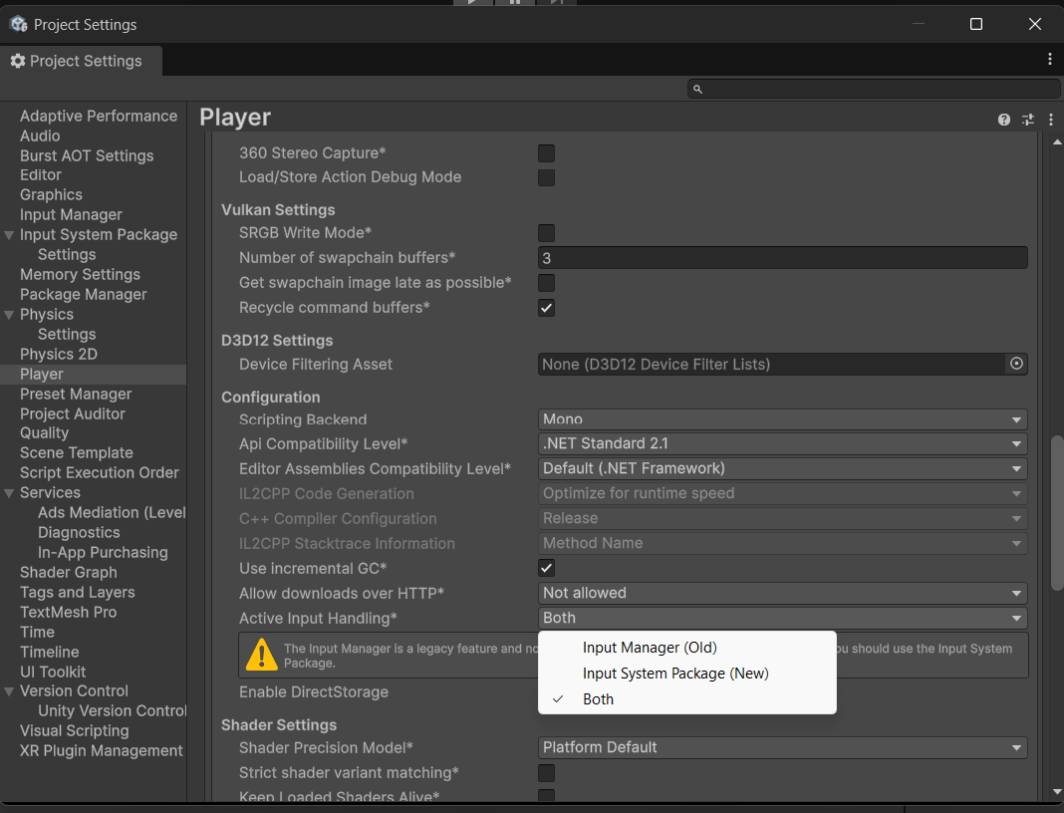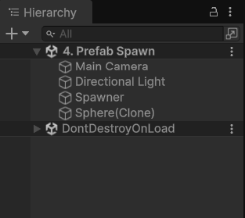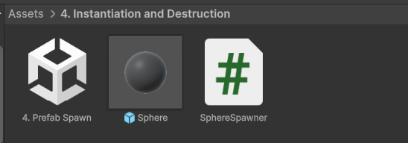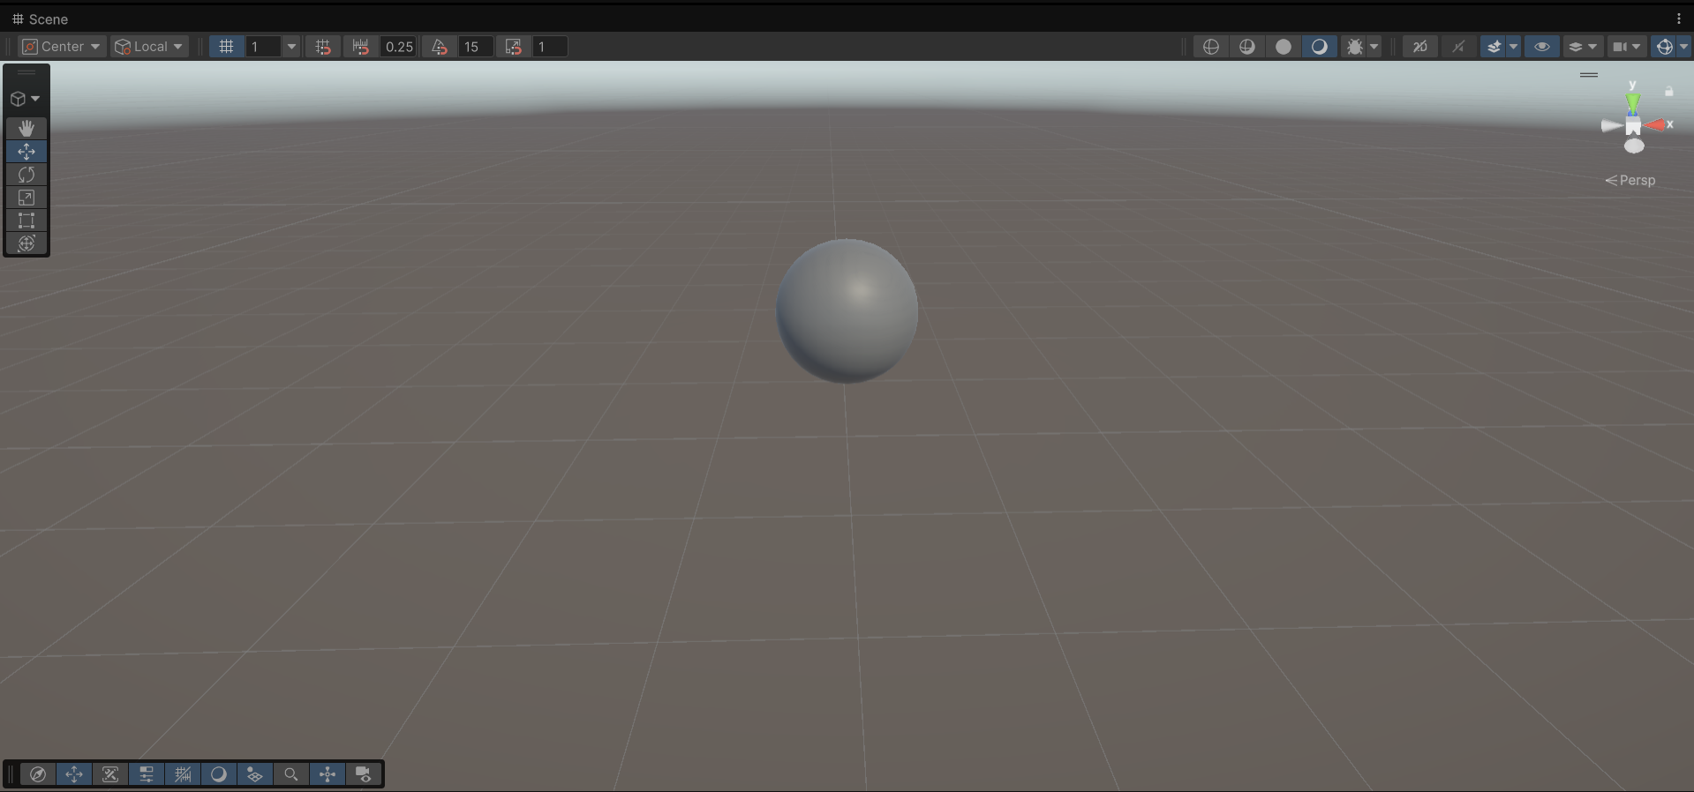

Lab 5: 3D Cube Movement

Objective
Work with 3D elements and player input by moving a 3D character cube using the Arrow Keys or WASD keys through Input.GetAxis().

Step 1: Create a New Unity Project
- Open Unity Hub.
- Click New Project.
- Select the 3D (Core) template.
- Enter a project name.
- Click Create Project.

Step 2: Create a New Scene
- In the Project Window, right-click inside the Assets folder.
- Select Create → Scene.
- Rename the scene as Cube Movement.
- Open and save the scene.

Step 3: Create a Ground Plane
- In the Hierarchy Window, right-click.
- Select 3D Object → Plane.
- Rename it as Ground.
- Reset the Transform component.

Step 4: Create a Player Cube
- Right-click in the Hierarchy.
- Select 3D Object → Cube.
- Rename it as Player.
- Set its position above the plane.
  - Position (0, 0.5, 0)

Step 5: Create a Movement Script
- In the Project Window, right-click inside the Assets folder.
- Select Create → C# Script.
- Rename the script as CubeMovement.
- Open the script in Visual Studio.

Step 6: Write the Script
Replace the default code with:

using UnityEngine;

public class CubeMovement : MonoBehaviour
{
[Header("Movement Settings")]
public float moveSpeed = 5f;

void Update()
{
// Get keyboard input
float horizontal = Input.GetAxis("Horizontal");
float vertical = Input.GetAxis("Vertical");

// Create movement direction
Vector3 movement = new Vector3(horizontal, 0f, vertical);

// Move the player
transform.Translate(movement * moveSpeed * Time.deltaTime);
}
}

Step 7: Attach the Script
- Return to Unity.
- Select the Player cube.
- Drag the CubeMovement script onto the Player cube.
- OR
- Click Add Component and select CubeMovement.

Step 8: Save and Run
- Save the scene (Ctrl + S).
- Click the Play button.
- Use the keyboard to move the cube.
Controls
Key | Action
W / Up Arrow | Move Forward
S / Down Arrow | Move Backward
A / Left Arrow | Move Left
D / Right Arrow | Move Right

Expected Result
- The Player cube moves smoothly across the plane.
- Both WASD and Arrow Keys control movement.
- Movement speed is controlled by the Move Speed variable in the Inspector.
- The cube can move freely in the X-Z plane.

Screenshots
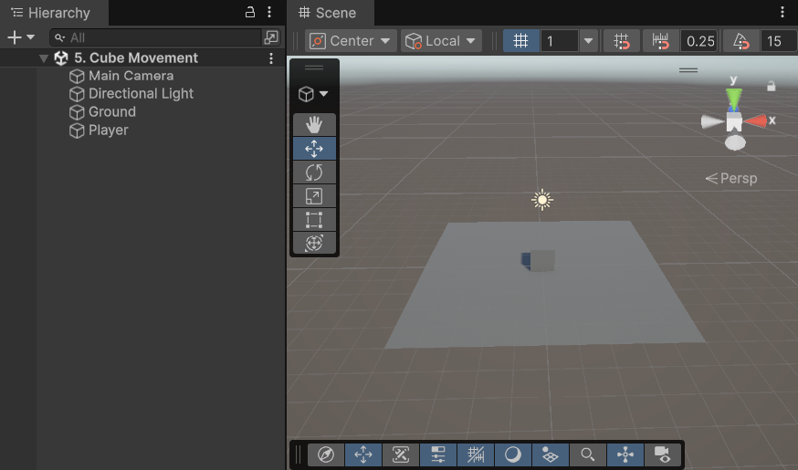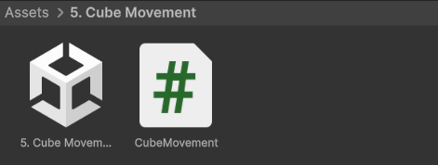

Lab 6: 2D Sprite Movement & Boundary Checks

Objective
Work with 2D elements and player input by moving a 2D character sprite using the Arrow Keys or WASD keys. Implement boundary checks to prevent the sprite from moving outside the game screen.

Step 1: Create a New Unity Project
- Open Unity Hub.
- Click New Project.
- Select the 2D Core template.
- Enter a project name.
- Click Create Project.

Step 2: Create a New Scene
- In the Project Window, right-click inside the Assets folder.
- Select Create → Scene.
- Rename the scene as Sprite Movement.
- Open and save the scene.

Step 3: Create the Player Sprite
- Right-click in the Hierarchy.
- Select 2D Object → Sprites → Circle.
- Rename it as Player.
- Set its position above the plane.
  - Position (0, 0, 0)

Step 4: Create a Movement Script
- In the Assets folder, right-click.
- Select Create → C# Script.
- Rename the script as SpriteMovement.
- Open the script in Visual Studio.

Step 5: Write the Script

Replace the default code with:

using UnityEngine;

public class SpriteMovement : MonoBehaviour
{
[Header("Movement Settings")]
public float moveSpeed = 5f;

[Header("Boundary Limits")]
public float minX = -8f;
public float maxX = 8f;
public float minY = -4f;
public float maxY = 4f;

void Update()
{
// Get player input
float horizontal = Input.GetAxis("Horizontal");
float vertical = Input.GetAxis("Vertical");

// Calculate movement
Vector3 movement = new Vector3(horizontal, vertical, 0f);

// Move sprite
transform.Translate(movement * moveSpeed * Time.deltaTime);

// Clamp position within boundaries
float clampedX = Mathf.Clamp(transform.position.x, minX, maxX);
float clampedY = Mathf.Clamp(transform.position.y, minY, maxY);

transform.position = new Vector3(
clampedX,
clampedY,
transform.position.z
);
}
}

Step 7: Attach the Script
- Return to Unity.
- Select the Player sprite.
- Drag the SpriteMovement script onto the Player GameObject.
- OR
- Click Add Component and add SpriteMovement.

Step 8: Configure the Boundary Values

In the Inspector, verify the following values:

Variable | Value
Move Speed | 5
Min X | -8
Max X | 8
Min Y | -4
Max Y | 4

These values can be adjusted depending on your camera size and game area.

Step 9: Test the Scene
- Save the scene (Ctrl + S).
- Click the Play button.
- Use the keyboard to move the sprite.
Controls

Key | Action
W / Up Arrow | Move Forward
S / Down Arrow | Move Backward
A / Left Arrow | Move Left
D / Right Arrow | Move Right

Expected Result
- The sprite moves smoothly in all directions.
- Both WASD and Arrow Keys control movement.
- The sprite cannot move beyond the defined screen boundaries.
- The character remains visible within the game area at all times.

Screenshots
